20IT6302: MACHINE LEARNING
HOME ASSIGNMENT-1 QUESTIONS
A.Y:2022-23
Q.No | Question | Course Outcome | BTL
1 | Consider the above confusion matrix and calculate TPR, FPR, TNR, FNR, accuracy by considering the COVID as positive class and non covid and viral pneumonia as negative class  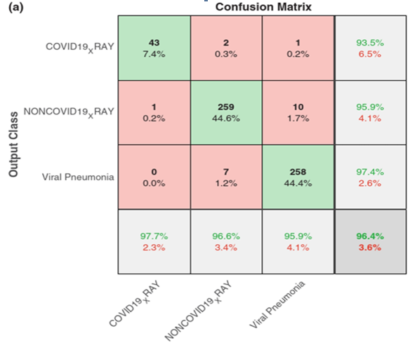 | CO1 | Apply
2 | 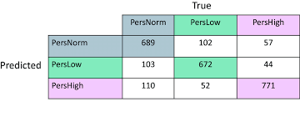  Consider the above confusion matrix and calculate TPR,FPR, TNR, FNR, accuracy by considering the persnorm and perslow as positive class and perhigh as negative class. | CO1 | Apply
3 | 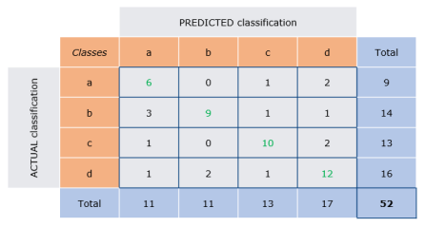  Consider the above confusion matrix and calculate TPR,FPR, TNR, FNR, accuracy by considering the a and d as positive class and b & c as negative class. | CO1 | Apply
4 | Consider the above confusion matrix and calculate TPR,FPR, TNR, FNR, accuracy by considering the a and b as positive class and c & d as negative class. | CO1 | Apply
5 | 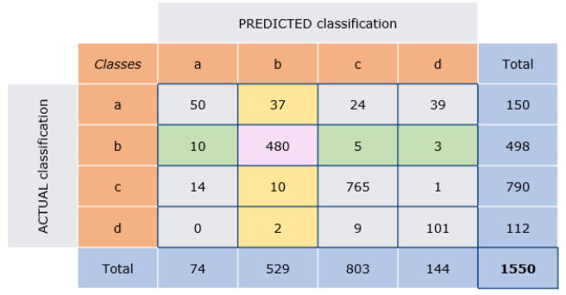  Consider the above confusion matrix and calculate TPR,FPR, TNR, FNR, accuracy by considering the a,c as positive class and b,d as negative class. | CO1 | Apply
6 | Consider the above confusion matrix and calculate TPR,FPR, TNR, FNR, accuracy by considering the a,b as positive class and c,d as negative class. | CO1 | Apply
7 | 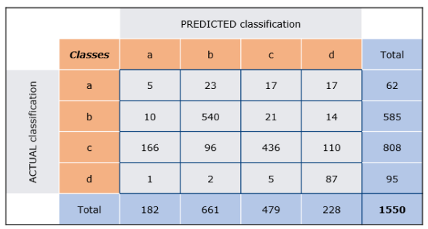  Consider the above confusion matrix and calculate TPR,FPR, TNR, FNR, accuracy by considering the a,c as positive class and b,d as negative class. | CO1 | Apply
8 | Consider the above confusion matrix and calculate TPR,FPR, TNR, FNR, accuracy by considering the a,b as positive class and c,d as negative class. | CO1 | Apply
9 | 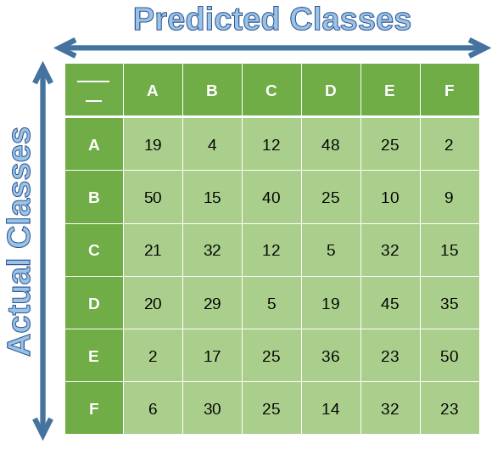  Consider the above confusion matrix and calculate TPR,FPR, TNR, FNR, accuracy by considering the A, E as positive class and C,D,B,F as negative class. | CO1 | Apply
10 | Consider the above confusion matrix and calculate TPR,FPR, TNR, FNR, accuracy by considering the A, B as positive class and C,D,E,F as negative class. | CO1 | Apply
11 | 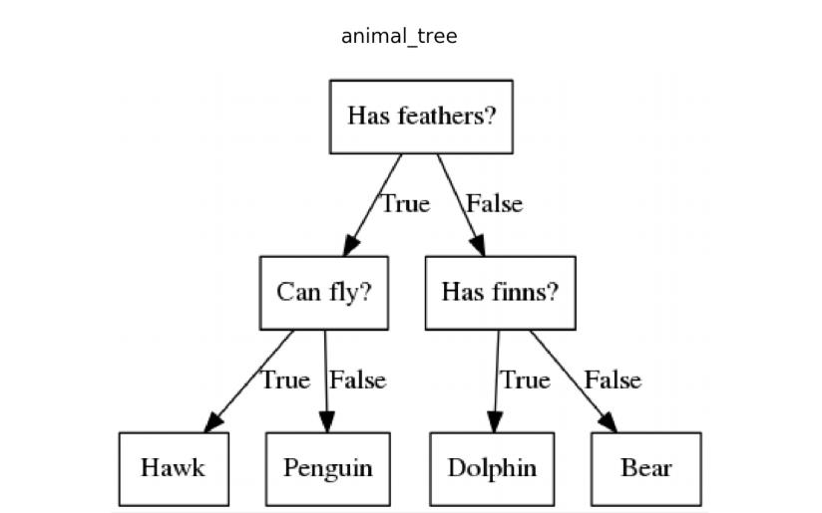  By cons idering the above clas s ifier evaluate it with res pect to the tes t given below. Calculate all the performance meas ures . Cons ider bear as pos itive clas s and all the remaining as negative clas s . | CO1 | Apply
  Has feathers | Can fly | Has finns | Clas s label
  True | True | True | Penguin
  True | Fas le | Fas le | Hawk
  Fals e | True | True | Bear
  Fas le | Fas le | Fas le | bear
  true | True | True | Hawk
  true | Fas le | Fas le | Penguin
  Fals e | True | True | Dolphin
  Fas le | Fas le | Fas le | bear
12 | 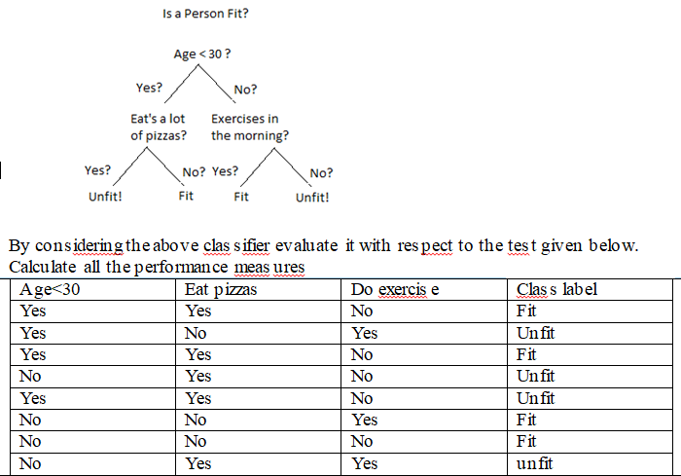 | CO1 | Apply
13 | If the predicted word vector is [-1,-1,+1,+1], find out the class label to be decided by consider the following output code matrix.  -1 +1 0 -1 0 0  +1 -1 +1 0 0 0  0 0 -1 +1 -1 +1  0 0 0 0 +1 -1 | CO1 | Apply
14 | If the predicted word vector is [+1,-1,+1,+1], find out the class label to be decided by consider the following output code matrix.  +1 -1 -1 -1  -1 -1 +1 -1  -1 +1 -1 -1  -1 -1 -1 +1 | CO1 | Apply
15 | If the predicted word vector is [+1,-1,+1,-1, +1, +1], find out the class label to be decided by consider the following output code matrix.  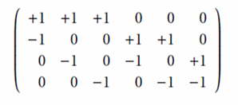 | CO1 | Apply
16 | If the predicted word vector is [-1,-1,-1,+1, +1, +1], find out the class label to be decided by consider the following output code matrix. | CO1 | Apply
17 | If the predicted word vector is [-1,-1,+1,-1, +1, -1], find out the class label to be decided by consider the following output code matrix. | CO1 | Apply
18 | If the predicted word vector is [+1,+1,-1], find out the class label to be decided by consider the following output code matrix.  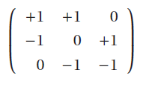 | CO1 | Apply
19 | If the predicted word vector is [-1,-1,+1,], find out the class label to be decided by consider the following output code matrix. | CO1 | Apply
20 | If the predicted word vector is [-1,0,+1], find out the class label to be decided by consider the following output code matrix. | CO1 | Apply
21 | If the predicted word vector is [+1,-1,+1,-1, +1], find out the class label to be decided by consider the following output code matrix.  0 +1 -1 -1 0  -1 -1 +1 0 -1  +1 0 -1 -1 +1  -1 -1 0 +1 0 | CO1 | Apply
22 | If the predicted word vector is [-1,+1,-1,+1, -1], find out the class label to be decided by consider the following output code matrix.  0 +1 -1 -1 0  -1 -1 +1 0 -1  +1 0 -1 -1 +1  -1 -1 0 +1 0 | CO1 | Apply
23 | If the predicted word vector is [-1,-1,+1,+1, +1], find out the class label to be decided by consider the following output code matrix.  0 +1 -1 -1 0  -1 -1 +1 0 -1  +1 0 -1 -1 +1  -1 -1 0 +1 0 | CO1 | Apply

Home Assignment Batches

Batch No | Roll Nos | Name
1 | 208W1A1267 | ALAVALA LAKSHMI SANKEERTHANA
1 | 208W1A1266 | ALAPATI RENUKA
1 | 208W1A1271 | ANNAM JITIN CHAND
2 | 208W1A1279 | CHEEDELLA KUSHMITHA
2 | 208W1A1274 | BATCHU ANUSH GUPTA
2 | 208W1A1275 | BHAGAVATULA APARNA
3 | 208W1A1288 | KANCHARLA PRABHU RAM
3 | 208W1A1276 | CH VAMSI SATYANARAYANA
3 | 208W1A1277 | CHAGARLAMUDI HEMAN SAI
4 | 208W1A1290 | KESIREDDY LAKSHMIKA
4 | 208W1A1282 | DHARMAPURI MAHITH PAUL
4 | 208W5A1207 | ANGADALA DIVYA SAI
5 | 208W1A1294 | KOWTHAVARAPU DHATRI PHANI PRIYA
5 | 208W1A1283 | GANDABATHULA SAI VAMSI
5 | 208W5A1208 | MAHALI TIRUMALA RAJU
6 | 208W1A1298 | MOHAMMAD NEELOFAR JAHA
6 | 208W1A12C7 | VEMULAPALLI SAIESH
6 | 208W1A1284 | JAGANNADHAM PAVANI
7 | 208W1A12A2 | NEELAM B V D SOUJITHA
7 | 208W1A1285 | JAGANNADHAM TEJA
7 | 208W1A1286 | JASTHI VIVEK VARDHAN
8 | 208W1A12A8 | PAVAN KUMAR MEKA
8 | 208W1A1287 | KAKUMANU CHRISTT VICTOR
8 | 208W5A1210 | TATA TEJASWINI
9 | 208W1A12C0 | SAINI ROSHINI
9 | 208W1A1291 | KOLLURI MOUNAV
9 | 208W5A1211 | THOKALA JOY JEEVAN
10 | 208W1A12C6 | TUMMALA VENKATA NAGA NYMISHA
10 | 208W1A1292 | KOMMAREDDY LEELA SATYA
10 | 208W1A12A0 | MOTAMARRI JAYA NAGA VENAKTA SAI
11 | 208W1A1268 | ALURI CHARAN
11 | 208W1A12C8 | YESU RAJU PARUSU
11 | 208W5A1212 | BURADA PAVAN
12 | 208W1A1270 | ANJU PRIYA MANAM
12 | 208W1A12A4 | PANCHUMARTHI YOGESWARA SAI SRINIVAS
12 | 208W1A12A6 | PARASA NIRUPAMA
13 | 208W1A1272 | ANNAM SIRI VARSHINI
13 | 208W1A12B0 | POLAVARAPU VENKATA NAGA RISHITHA CHOWDARY
13 | 208W1A12B1 | POLUKONDA GUNA SRI MANJUNADH
14 | 208W1A1273 | BANAVATHU MOUNICA KAUMUDHI
14 | 208W1A12B2 | PORITIGADDA LIKHITHA
14 | 208W1A12B3 | POTLURU SRI SASHANK
15 | 208W1A1278 | CHATRASI AMAR LOKESH VENKATA SIVA SAI
15 | 208W1A12B4 | POTNURU RAJU DEEPAK
15 | 208W1A12B5 | PRATHIPATI VASAVI
16 | 208W1A1280 | CHENNAREDDY LAKSHMI NARASIMHAM
16 | 208W1A12B6 | PULAPAKA VARUN KUMAR
16 | 208W1A12B7 | RANGISETTI LAKSHMI SRAVANTHI
17 | 208W1A1281 | CHINAMUTTEVI DEEPIKA
17 | 208W1A12B8 | RAYIDI SAI SREE SRESTA
17 | 208W1A12B9 | REVALAMADUGU RAGHU VARMA
18 | 208W1A1299 | MOHAMMAD RIZWANULLAH
18 | 208W1A12C1 | SAMBANA HARSHITHA
18 | 208W1A12C2 | SAMSANI ABHI VENKATA SAI
19 | 208W1A1296 | MAREEDU GEETHIKA
19 | 208W1A12C3 | SHETTY VENU
19 | 208W1A12C4 | TEKI BHARGAV TIRUPATHI KAMARAJU
20 | 208W1A12A3 | PALLETI DIVYA SREE
20 | 208W1A12C5 | TULLURI NAGA VENNELA
20 | 208W5A1209 | PALLAPTI LATHASRI
21 | 208W1A12A5 | PANITINI MONICA
21 | 208W1A1293 | KOMMINENI UDAY KIRAN
21 | 208W1A12A9 | PERNI DEVI DIVYA SRI
22 | 208W1A1269 | AMPALAM YAMUNA
22 | 208W1A1295 | MANOHAR RAJ KOKKILIGADDA
22 | 208W1A1289 | KANTAMNENI MAHITA
23 | 208W1A1297 | MEDISETTY LIKHITHA
23 | 208W1A12A1 | NAGARAJU AJAY KUMAR VARMA

Question.  No’s | Batch No | Question.  No’s | Batch No
1, 13 | 1 | 1, 23 | 13
2, 14 | 2 | 2, 22 | 14
3, 15 | 3 | 3, 21  4,20 | 15
4, 16 | 4 | 4, 20 | 16
5, 17 | 5 | 5, 19 | 17
6, 18 | 6 | 6, 18 | 18
7, 19 | 7 | 7, 17 | 19
8, 20 | 8 | 8, 16 | 20
9, 21 | 9 | 9, 15 | 21
10, 22 | 10 | 10, 14 | 22
11, 23 | 11 | 11, 13 | 23
12, 13 | 12

